DEFINE:
Problem: Inconsistent application of evidence- based preoperative practices to prevent surgical site infection with the emphasis on preoperative skin cleansing with Chlorhexidine Gluconate.
Goals: Engage multidisciplinary group to evaluate preoperative care of the surgical patient at all points of entry into the organization and address opportunities for improvement and standardize care (education, preoperative showers/baths) to ensure:
- Elimination/reduction of surgical site infections (outcome measure)
- 100% of patients undergoing surgical procedures at CRMC will have appropriate preoperative bathing with a CHG containing product by one of two methods (process measure):
- The patient will perform a shower the night before and the morning of surgery with a liquid CHG containing product.
- CRMC staff will perform CHG bath using 2% CHG cloths for those patients who are unable to perform their own shower.
- 100% Documentation of preoperative bath/shower as per policy.
MEASURE:
Through targeted surgical site surveillance, Infection Prevention will review medical records for surgical site infections and documentation of appropriate preoperative bathing. Compliance report will be generated monthly using the included NHSN operative codes and pulling documentation from the EMR. In addition CHG process mapping was completed for all units/departments to identify current preoperative bathing practices.
ANALYZE and IMPROVE:
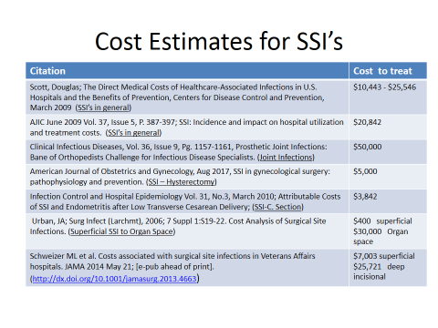

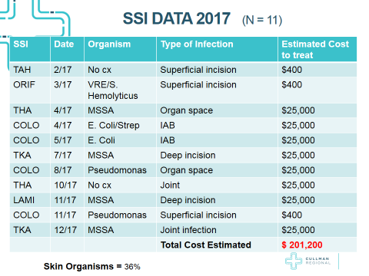

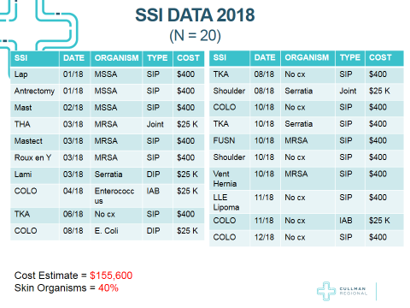

CHG Preoperative Bathing Process Mapping :
Clinical Area and CHG Process | Yes | No | N/A | Comments
Emergency Department
Are patients going directly to OR bathed with CHG? |  | X
Is CHG soap PAR level stocked? |  | X
Is CHG cloths (Sage Wipes) stocked? |  | X
Does CHG bath require MD order? |  | X
Do patients receive one bath or two |  |  | X | neither
Where is bath documented, if provided? | X |  |  | T-system in progress section
Women’s Services | Yes | No | N/A
Are induced/laboring patients bathed prior to C Section? |  | X |  | No preoperative bathing occurs
If yes, with what? |  |  | X
If CHG, how do you ensure patients receive CHG? |  |  | X
Is CHG soap PAR level stocked? |  | X
Is CHG cloths (Sage wipes) stocked? |  | X
Does CHG bath require MD order? | X
Where is bath documented if provided? |  |  | X
Scheduled C Section bathed prior to C Section? |  | X
If yes, with what? |  |  | X
If CHG, how do you ensure patients receive CHG? |  |  | X
Is patient told to purchase CHG soap and bathe? |  |  | X
Are patients provided instructions on how to apply CHG? |  |  | X
How do you verify patient used CHG? |  |  | X
Where is the bath documented, if completed? |  |  | X
What is the process if the patient did not apply CHG? |  |  | X
What happens if the patient doesn’t go through pre-admit? |  |  | X
Do patients receive one bath or two |  |  | X
Outpatient Surgery/Same Day Admit | Yes | No | N/A
Is CHG soap given to patient in pre-admit? | X |  |  | for THA, TKA, Shoulder, Dr. Ward’s patients (PLIF-fusion)
Is CHG wipes (Sage) given to patients in pre-admit? |  | X
Is patient told to purchase CHG soap and bathe? |  | X
Are patients provided instruction on how to apply CHG? | X |  |  | for THA, TKA, Shoulder, Dr. Ward’s patients (PLIF-fusion)
Where is bath documented, if completed? | X |  |  | Preop E form nursing notes patients are asked if they took 2 CHG baths.
What is the process if patient did not apply CHG? | X |  |  | for THA, TKA, Shoulder, Dr. Ward’s patients (PLIF-fusion) pt. is wiped down with Sage Cloth
What happens if patient doesn’t go through pre-admit?
How do these patients receive CHG?
Inpatient Units | Yes | No | N/A
Does CHG bath require an MD order? | X
Do inpatients receive preop baths with 2% CHG prior to surgery? | X |  |  | Yes, Hibiclens
Are patients provided instruction on how to apply CHG? | X
If patients are not able to shower are CHG wipes (Sage Cloths) provided? |  |  | X
Is staff performing CHG wipes for those patients who are unable to perform? |  |  | X
Is CHG soap PAR level stocked? | X
Is CHG cloths (Sage Wipes) stocked? |  |  | X | Not available
Does CHG bath require MD order? | X
Do patients receive one bath or two |  |  |  | Based on orders
Where is bath documented, if provided? |  |  |  | Nursing Flowchart
Outside Surgical Services (Cardiovascular, Interventional Radiology) | Yes | No | N/A
Is CHG soap given to patient in pre-admit? |  | X
Is CHG wipes (Sage) given to patients in pre-admit? |  | X
Is patient told to purchase CHG soap and bathe? |  | X
Are patients provided instruction on how to apply CHG? |  | X
How do you verify patient used CHG? |  |  | X
Where is bath documented, if completed? |  |  | X
What is the process if patient did not apply CHG? |  |  | X
What happens if patient does not go to pre-admit? |  |  | X
How do these patients receive CHG? |  |  | X
Policy and Procedure | Yes | No | N/A
Existing policy for preprocedure skin cleansing/bathing | X
Is CHG cleansing agent of choice? |  | X
Alternatives identified for allergy to CHG? |  | X
Exclusion criteria? |  | X
Policy for preprocedure hair removal? | X
Does it state when, where, and how hair removal will occur? |  | X
Electric razors with disposable single-use heads used? | X
If clipping in OR, is vacuum used?

Findings:
CHG Bathing:
- CHG bathing appears to be hardwired for the ortho cases that go through PAT.
- Inpatients get CHG bath only if MD orders it. Maternity, ED, Inpatients, and Cardiovascular Services have no process for preoperative CHG bathing.
- The inpatient preoperative checklist only asks if patient has had a bath within 12 hours.
- 55% of elective cases from Surgeon Office Practices are coming through CRMC PAT
- 55% of those elective cases that do not go through PAT at CRMC do not receive any instruction on CHG preoperative bathing.
IMPROVEMENT PLAN:
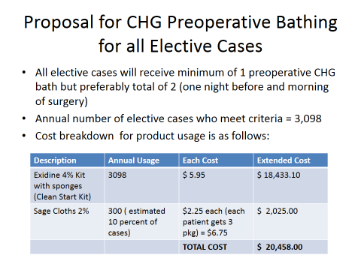
- Review differing practices for inpatients, outpatients, and patients entering via ED and consider specialty groups (e.g. C Sections; scheduled vs. emergent, Cardiovascular Services).
- Electronic and other documentation tools to be developed to capture documentation of CHG preoperative bathing.
- Preoperative Bathing Policy review and revision and CBL development for mandatory staff education on the new process.
- Develop patient educational materials for CHG Bathing to be distributed with product.
- Implement CHG preoperative bathing reminders through email and text using the BD Clean Start program.
- Obtain and stock in all areas CHG to provide to patients for bathing. Make product available in PAT for pick up and in Urgent Care for distribution between 4:30pm and 9:00pm when PAT closes. Ensure product availability in OB/GYN offices for distribution to patients who do not come through PAT
- Communication and Education to all stakeholders regarding CHG preoperative bathing process and expectations.

CONTROL:
Control to sustain the gain and demonstrate a hardwired process as seen by:
- Physician committee(s) approved policy for CHG preoperative bathing that does not require staff to “remember” to order preoperative bath/shower.
- Ongoing evaluation of compliance through the generation of automated monthly reports.
- Ongoing targeted SSI Surveillance to track surgical site infections.

