ACCURATE BLOOD PRESSURE MEASUREMENT

The current method used most often in the hospital setting for accurate measurement of blood pressure is the oscillatory method, or automated blood pressure machine, which tends to underestimate both systolic and diastolic readings by as much as 10 mm Hg^{1,2} In the clinic setting and physician offices, blood pressure measurement is often used with the aneroid (mechanical type with a dial) sphygmomanometer. Refer to Table 1 for steps in obtaining accurate blood pressure measurement and Figure 1 for recommended cuff sizes.

Table 1: Steps for Obtaining Accurate Blood Pressure Measurements³
Step 1: Prepare equipment: | a. Mercury sphygmomanometer is gold standard, can use  validated equivalent automated equipment  b. Check cuff for any defaults  c. Obtain correct size cuff: width of bladder 40% of  circumference and encircle 80% of arm (See Figure 1)
Step 2: Prepare the patient: | a. Use a sitting or semi-reclining position with back supported  and arm at heart level  b. Patient to sit quietly for 5 minutes prior to measurement  c. Bare upper arm of any restrictive clothing  d. Patients feet should be flat, not dangling from examination  table or bed, and her legs uncrossed  e. Assess any recent (within previous 30 minutes) consumption of  caffeine or nicotine. If blood pressures are at the level that  requires treatment, consumption of nicotine or caffeine should  not lead to delays in instituting appropriate anti-hypertensive  therapies
Step 3: Take measurement: | a. Support patients arm at heart level, seated in semi-fowlers  position  b. For ausculatory measurement: use first audible sound  (Kortokoff I) as systolic pressure and use disappearance of  sound (Kortokoff V) as diastolic pressure  c. Read to the nearest 2 mm Hg  d. Instruct the patient not to talk  e. At least one additional readings should be taken within 15  minutes  f. Use the highest reading  g. If greater than or equal to 140/90, repeat within 15 minutes and  if still elevated, further evaluation for preeclampsia is  warranted.  Do not reposition patient to either side to obtain a lower BP. This will give you a false reading.
Step 4: Record Measurement | Document BP, patient position, and arm in which taken
Adapted from Peters RM (2008) High blood pressure in pregnancy. Nursing for Women’s Health, Oct/Nov, pp.410-422.

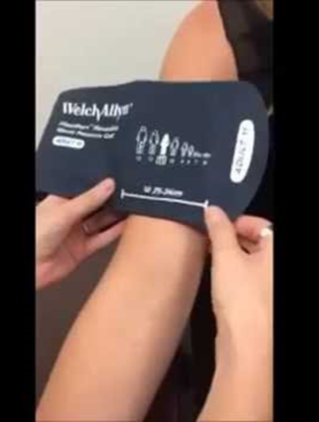
Figure 1: Recommended cuff sizes
Arm Circumference (cm) | Cuff Size
22-26 | “Small Adult”: 12x22cm
27-34 | “Adult”: 16x30cm
35-44 | “Large Adult”: 16x36cm
45-52 | “Adult Thigh”: 16x42cm

Accurate blood pressure measurements in obese women can be quite challenging and it is extremely important to use an appropriate sized cuff. In women with an upper-arm circumference of more than 34cm, large adult cuffs or thigh cuffs can be used to improve blood pressure accuracy. For upper-arm measurements greater than 50cm, the American Heart Association recommends using a cuff on the forearm and feeling for the appearance of the radial pulse at the wrist to estimate systolic blood pressure. However, the accuracy of forearm measurement is not reliable.⁴

REFERENCES

- Natarajan P, Shennan A, Penny J, Halligan A, de Swiet M, Anthony J. Comparison of auscultatory and oscillometric automated blood pressure monitors in the settingof preeclampsia. American Journal of Obstetrics and Gynecology. 1999;181 (5 Pt1):1203-1210.
- Ogedegbe G, Pickering T. Principles and techniques of blood pressure measurement. Cardiology Clinics. 2010;28(4):571-586.
- Peters R. High blood pressure in pregnancy. Nursing for Womens Health. 2008;12(5410-421; quiz 422).
- Pickering T, Hall J, Appel L, et al. Recommendations for blood pressure measurement in humans and experimental animals: part 1: blood pressure measurement in humans: a statement for professionals from the Subcommittee of Professional and Public education of the American Heart Association Council on high blood pressure research. Hypertension. 2005;45:142.

Adapted from content of the California Maternal Quality Care Collaborative Toolkit, Improving Health Care Response to Preeclampsia, 2014

